Program Book



**Community Service Project**

AP STATE COUNCILOF HIGHER EDUCATION

(A STATUTORYBODY OFGOVERNMENT OF ANDHRAPRADESH

# COMMUNITY SERVICE PROJECT REPORT

On

UTILISATTION OF ELECTRICITY TO FARMERS AND RELATED ISSUES

By

# SHAIK SHAREENA (22JN1A3352)

Under the guidance of

**Dr. P. KALYANI, MTech, PhD**

**DEPARTMENTOF**

**COMPUTER SCIENCE AND ENGINEERING**



**Sree Venkateswara College of Engineering**

NAAC ‘A’ Grade Accredited Institution, An ISO 9001::2015 Certified Institution ( Approved by AICTE and New Delhi and Affiliated to JNTU,Ananthapur)

North rajupalem(Vi), Kodavalur (M), S.P.S.R. Nellore(Dt)-524316

**2023-2024**

**Program Book**

**For**

**Community Service Project**

**Name of the Student :** SHAIK SHAREENA

**Name of the College :** SREE VENKATESWARA COLLEGE OF ENGINEERING

**Registration Number :** 22JN1A3352

**Period of CSP :** 6 WEEKS **From:** 15-May-2024 **To:** 26-June-2024

**Title :** UTILISATTION OF ELECTRICITY TO FARMERS AND RELATED ISSUES

**Name &Address of Community/Habitation**: North Rajupalem(V), Kodavalur(M), Nellore(D)

#### 

#### 

**Community Service Project Report**

**Submitted in accordance with the requirement or the degree of B.Tech**

Name of the College : SREE VENKATESWARA COLLEGE OF ENGINEERING

Department : ARTIFICIAL INTELLIGENCE AND MACHINE LEARNING

Name of the Faculty Guide : Mrs. Dr. P. Kalyani

##### Duration of the CSP : From: 15-May-2024 To: 26-June-2024

Name of the Student : SHAIK SHAREENA

Program of Study : B. TECH Year of Study : 3rd year

Register Number : 22JN1A3352

Date of Submission :

# Student’s Declaration

I **SHAIK.SHAREENA,** a student of **III year B.Tech** Program, Reg. No. **22JN1A3352** of the **Department of CSE(AI&ML)**, in **SREE VENKATESWARA COLLEGE OF ENGINEERING** College do here by declare that I have completed the mandatory community service project **from May 13 to July 6 in Utilization of electricity to farmers and related issues** Program under the Faculty Guideship of **Dr.P.Kalyani** Department of **ARTIFICIAL INTELLIGENCE AND MACHINE LEARNING in SREE VENKATESWARA COLLEGE OF ENGINEERING.**

(Signature and Date)

**Endorsements**

**Faculty Guide**

**Head of the Department**

**Principal**

**Certificate from Official of the Community**

This is to certify that SK.SHAREENA Reg. No 22JN1A3352 of SREE VENKATESWARA COLLEGE OF ENGINEERING underwent community service in UTILIZATION OF ELECTRICITY TO FARMERS AND RELATED ISSUES from 13th May 2024 to 6th July 2024

The overall performance of the Community Service Volunteer during his/her community service is found to be……….(Satisfactory/Good).

**Authorized Signatory with Date and Seal**

## ACKNOWLEDGEMENT

I would like to take this opportunity to acknowledge everyone who has helped us in every stage of this project. I express my deep sense of gratitude to all those who have been instrumental in preparation of this project.

My most sincere and grateful acknowledgments to **Dr. Guna S hekhar CHAIRMAN** who took keen interest and encouraged us in every effort through out this course.

I own my gratitude to Dr.C.Prakash Rao M.Tech,Phd**,Principal SREE VENKATESWARA COLLEGE OF ENGINEERING, NELLORE** and Dr.P.Kalyani M.Tech,Phd **Associate professor & Head of the department, Computer Science and Engineering,** for giving us the opportunity to do this community service project on the topic **Utilization of electricity to farmers and related issues.**

I take this opportunity to express my sincere deep sense of gratitude to our guide

**Dr.P.Kalyani,Mtech,phd Department of COMPUTER SCIENCE AND ENGINEERING,** for her significant suggestions and help in every respect to accomplish the report.

I would like to thank Community Service Project coordinator Mrs.T.Anusha M.Techfor his persisting encouragement and keen interest in discussions have benefited us to an cannot be

Also, I would like to thank FARMERS AND NORTH RAJUPALEM GRAMA PANCHAYATH, for their constant support and encouragement.

Finally, I am thankful to the technical and non-technical staff of SREE VENKATESWARA COLLEGE OF ENGINEERING, NELLORE, and also parents, friends and all my well-wishers for their assistance in finishing the Community Service Project Successfully.

Sk.Shareena

22JN1A3352

**CHAPTER-1**

**EXECUTIVE SUMMARY**

Introduction:

Electricity plays a key role in the agricultural sector as it is used for powering a wide range of equipment and systems that facilitate production. Farms and crop fields require irrigation systems and proper lighting for increased growth and productivity. Electric pumps are used to supply the water for irrigation and lighting for the crops. In addition, electric fencing is employed to protect crops from pests and to manage animal control.

Farmers utilize electricity for various purposes in modern agriculture. This includes powering irrigation systems for efficient water management, providing lighting to optimize crop growth, using electric pumps for irrigation, and employing electric fencing for pest control and animal management. These applications enhance productivity, efficiency, and sustainability in farming practices.

Objectives:

✧ Enhanced productivity

✧Efficient irrigation

✧Mechanization

✧storage and processing

✧Automation

✧Diversification

**CHAPTER-2**

**OVERVIEW OF THE COMMUNITY**

The utilization of electricity in rural communities profoundly impacts every aspect of life, catalyzing social, economic, and developmental change. Access to electricity enhances daily routines by providing lighting for safe nighttime activities and powering appliances that improve domestic comfort. Economic opportunities expand as electricity enables small businesses to operate efficiently and facilitates the use of electric tools in agriculture, enhancing productivity and income generation. Education receives a significant boost with access to computers, internet connectivity, and well-lit study environments, while healthcare services benefit from refrigeration for storing vaccines and powering medical equipment. Beyond immediate benefits, electrification fosters community cohesion through illuminated public spaces and supports local governance by enabling communication and information dissemination. Sustainable electrification initiatives, often supported by government programs and NGOs, not only ensure reliable access to electricity but also empower communities to manage and maintain infrastructure, ensuring long-term viability and resilience.

In many rural communities, the utilization of electricity is transformative. From enhancing daily living with basic amenities like lighting and cooking facilities to enabling economic activities such as small-scale enterprises and agricultural productivity through electric pumps for irrigation, electricity plays a pivotal role. It supports education by facilitating access to modern learning tools and healthcare by powering medical equipment and refrigeration. Moreover, electricity fosters community development by lighting streets, powering community centers, and improving overall safety. Despite challenges like initial costs and infrastructure limitations, efforts by governments, NGOs, and local communities ensure sustainable electrification, promoting not only access but also the long-term benefits of improved quality of life and economic opportunities.

**SOCIO ECONOMIC CONDITIONS:**

* Income Levels
* Affordability
* Infrastructure
* Government Policies
* Cultural Attitudes
* Education
* Technological Literacy
* Community Cohesion

CHAPTER-3

COMMUNITY SERVICE PART

Participating in a Community Service Project (CSP) focused on the utilization of free electricity for farmers offers us an invaluable opportunity to develop a broad range of life skills, values, and technical competencies.

Through such projects, we must identify the specific energy needs of farmers, devise practical and innovative solutions, and implement these solutions effectively. Additionally, working in teams on these projects promotes essential teamwork skills. We learn to communicate effectively, collaborate with diverse groups, and leverage each team member's strengths to achieve common goals.

Community engagement is a significant value gained from CSPs. By working closely with local farmers and community members, students develop a stronger connection to their community.

In conclusion, participating in a CSP focused on the utilization of free electricity for farmers equips students with a diverse set of skills and values. They develop critical life skills such as problem-solving, teamwork, and time management, while also fostering empathy, responsibility, and a sense of community engagement.

Skills learned from this topic:

* Problem-solving
* Teamwork
* Leadership
* Responsibility
* Technical Skills
* Project management
* Data analysis
* Addressing Farmer Issues
* Electricity accessibility
* Cost savings

**ACTIVITY LOG FOR FIRST WEEK**

|  |  |  |  |
| --- | --- | --- | --- |
| **DAY**  **&**  **DATE** | **BRIEF DESCRIPTION OF THE DAILY ACTIVITY** | **LEARNING OUTCOME** | **Person**  **In-charge Signature** |
| Day-1 | Studied the guidelines of community service Project. | Understood the importance of Community Service Project. In the curriculum and got the Clear idea of the project. |  |
| Day-2 | I have selected the topic “UTILISATION OF ELECTRICITY TO FARMERS AND RELATED ISSUES” and started searching for a suitable place for the smooth conduct of the project. | The process helped me to easily select the suitable place for the project. |  |
| Day-3 | I went to nearby Sachivalayam for seeking permission for the smooth conduct of the project. | It helped me how to speak with higher officials. |  |
| Day-4 | I have surveyed some farmers about getting electricity. | Got the information about need of electricity in farming. |  |
| Day-5 | I spent time with the farmers and interacted about how much time they are getting electricity. | I got an idea about electricity provided for farmers. |  |
| Day-6 | We conducted a survey to know the details of farmers. | I found about the time they are spending in their farms and got to know about the usage of electricity. |  |

**WEEKLY REPORT**

**Week-1 (From dt: 13-05-2024 To dt: 18-05-2024)**

|  |
| --- |
| **Objective of the Activity Done: Utilisation of electricity to farmers and related issues***.* |
| **Detailed Report:** |
| On day-1:  In order to start the project   * Studied the guidelines of the project. * Understood the inclusion of Community Service project in the curriculum. * Pre-planned theWeek-1 schedule of the project. * Understood the changes come in the students behaviour after CSP.. |
| On day-2:   * I have selected the topic “UTILISATION OF ELECTRICITY TO FARMERS AND RELATED ISSUES”. * I have started searching the suitable place for my project. * In the process of selecting place, I came to know what are essential requirements required for selecting the suitable place for the project. |
| On day-3:  As a part of my project,   * I have visited nearby sachivalayam and met VRO. * Took permission from VRO for smooth conduct of my project. * I have explained him about my project. |
| On day-4:  I have surveyed some farmers and questioned them on utilisation of electricity to farmers:   * How much electricity is needed for a day? * Is electricity provided free? * Does free electricity come under government? |
| On day-5:   * I have observed the work done by the farmers on the field. * I started asking related question about providing electricity. * I got an idea about providing electricity to farmers. * I got the real time experience of farming. |
| On day-6:  As a part of final day of the week:   * I seeked an information about the need of electricity in villages to farmers. * I got an awareness how to interact with people. * I gained knowledge about our project and known how to interact with people. |

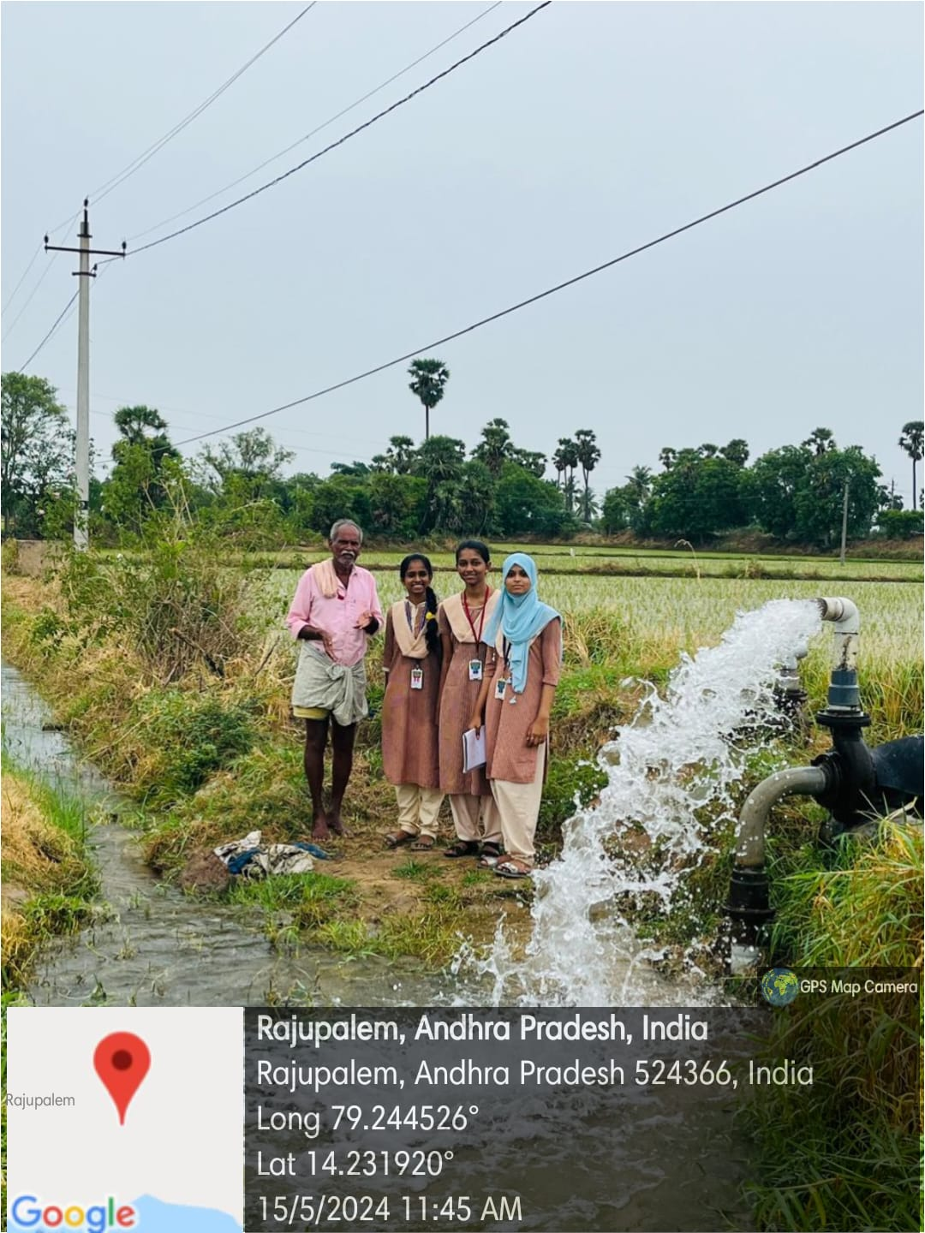

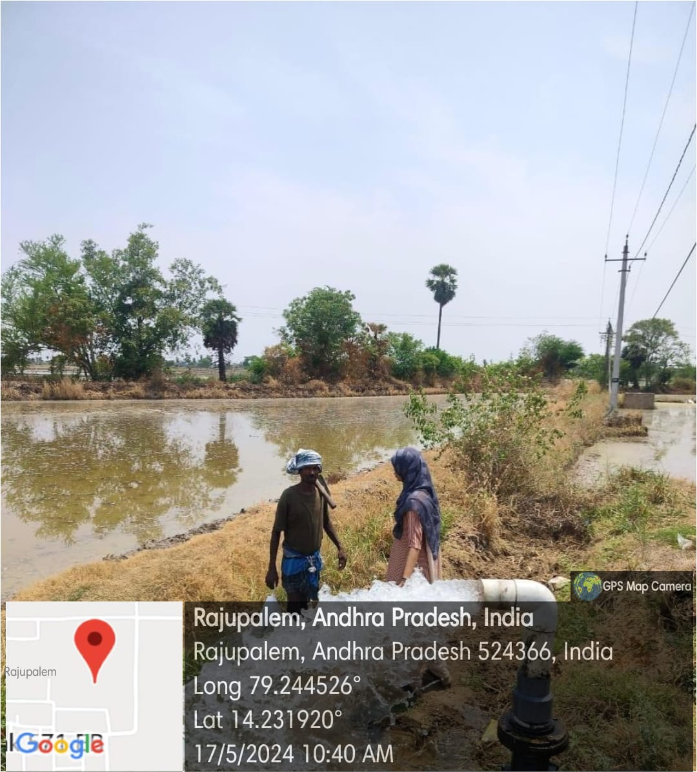

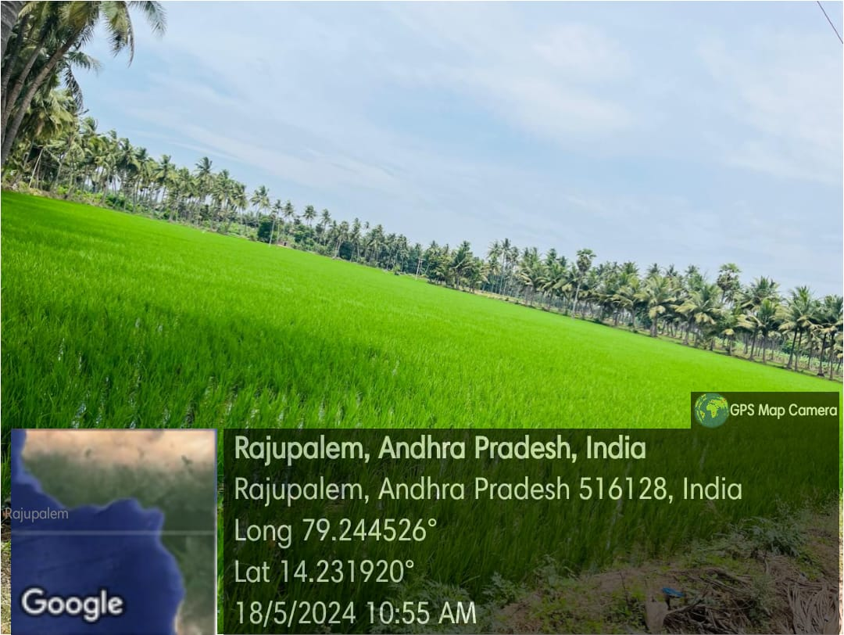

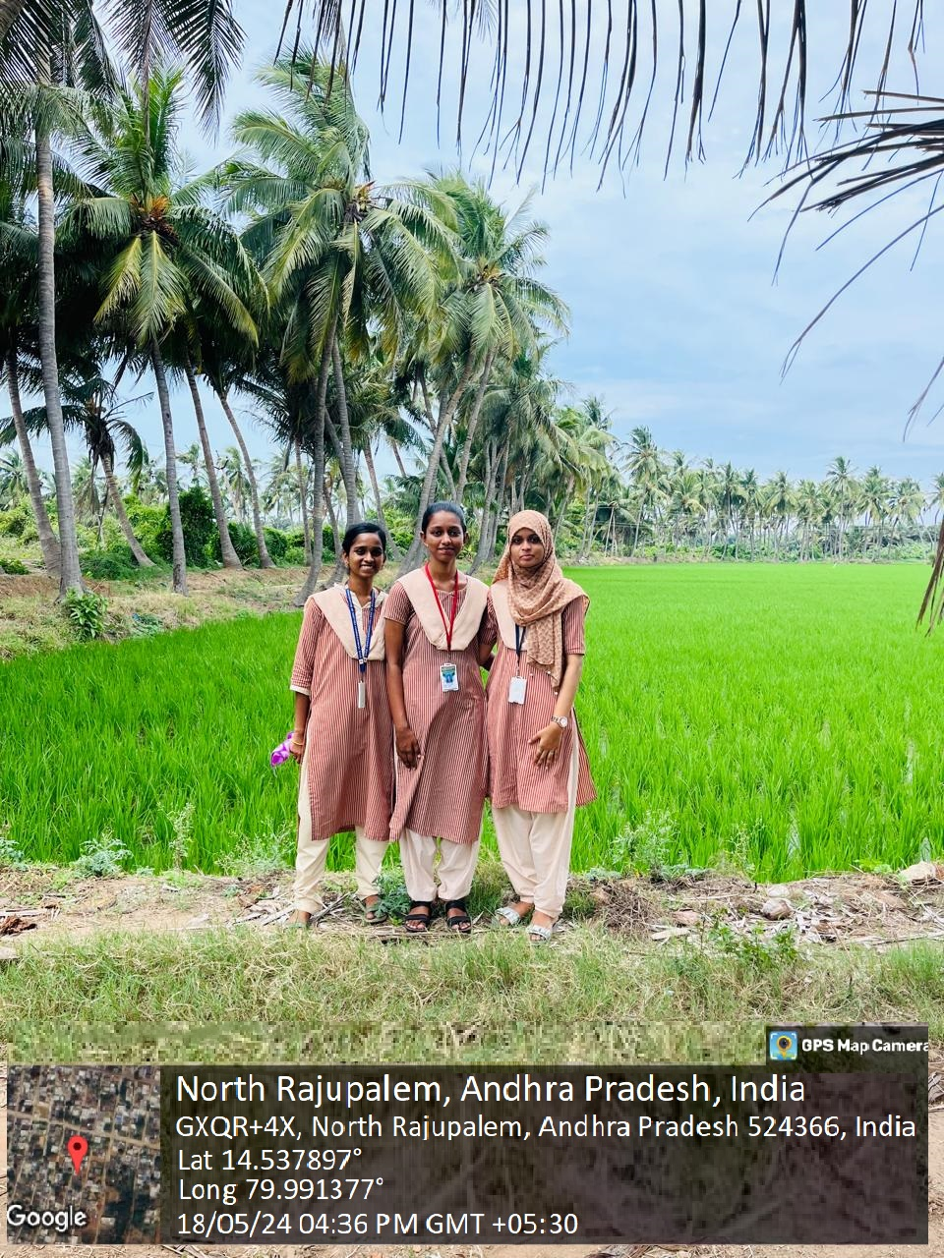

**ACTIVITY LOG FOR SECOND WEEK**

|  |  |  |  |
| --- | --- | --- | --- |
| **DAY**  **& DATE** | **BRIEF DESCRIPTION OF THE DAILY ACTIVITY** | **LEARNING OUTCOME** | **Person In-charge**  **Signature** |
| Day-1 | Visiting a village | We visited North Rajupalem, Nellore district to interact with people to know more. |  |
| Day-2 | Introduction of Electricity | Agriculture is the art and science of cultivating the soil, growing crops and raising livestock. |  |
| Day-3 | Uses of electricity in farming | >Motors  >Sprinkle Irrigation  >Drip irrigation |  |
| Day-4 | Usage of motor | The motors are used to power a variety of machinery, including plowing, tilling, and harvesting equipment. |  |
| Day-5 | Usage of electricity in a day | On an average a village called Rajupalem has a total electricity  demand of approximately 1,826 kWh per day. |  |
| Day-6 | Importance of electricity for a particular crop | Paddy fields require consistent water supply for optimal growth. Electric pumps and tube wells powered by electricity facilitate efficient irrigation, ensuring that  the crop receives adequate water throughout its growth cycle. |  |

**WEEKLY REPORT**

**Week-2 (From dt: 20-05-2024 To dt: 25-05-2024)**

|  |
| --- |
| **Objective of the Activity Done: Utilization of free electricity to farmers and related issues***.* |
| **Detailed Report:** |
| On day-1:   * On this day our team visited Rajupalem in the Nellore district and conducted survey. * The village is known for its traditional farming practices. * We identified area is fertile and well-suited for growing a variety of crops due to the favorable climatic conditions. |
| On day-2:   * We then started to know about farming and conditions that they grow. * We observed, farming in Rajupalem is characterized by a mix of traditional and modern agricultural practices. * We observed the fertile soils and favorable climatic conditions make Rajupalem an   ideal location for diverse agricultural activities. |
| On day-3:   * We asked them how they use electricity for their purposes. * We came to know, some farmers use electricity for drip and sprinkler irrigation. * And electric threshers to separate grains from the harvested crops, saving time and labor. |
| On day-4:   * We noticed motors are critical component in modern farming. * We questioned them regarding usage of motors. * Motors are extensively used to power electric water pumps, which draw water from wells, canals, and tanks to irrigate fields. |
| On day-5:   * We surveyed how often they use electricity for a day. * We gathered information is that, electricity is good for one time a day and not for another time. |
| On day-6:   * We observed mostly that, paddy is the most common growing crop in Rajupalem. * For this they use electric water pumps, drip and sprinkler systems in giving most importance to electricity * And finally, we submitted this week report to our respected guide. |

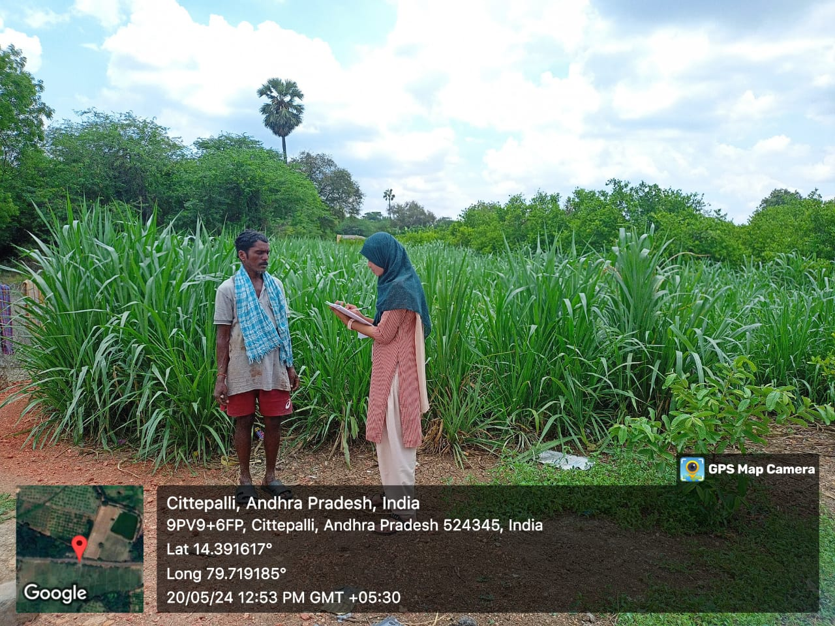

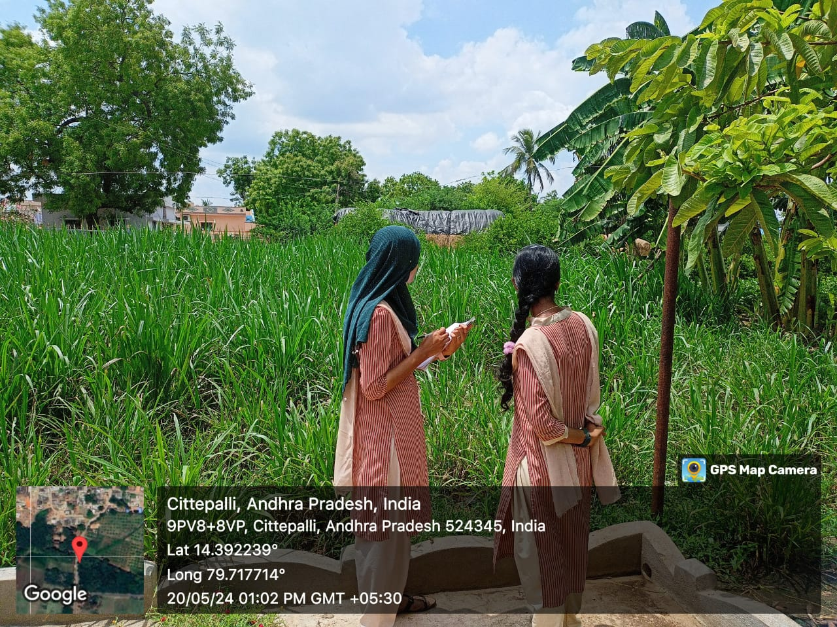

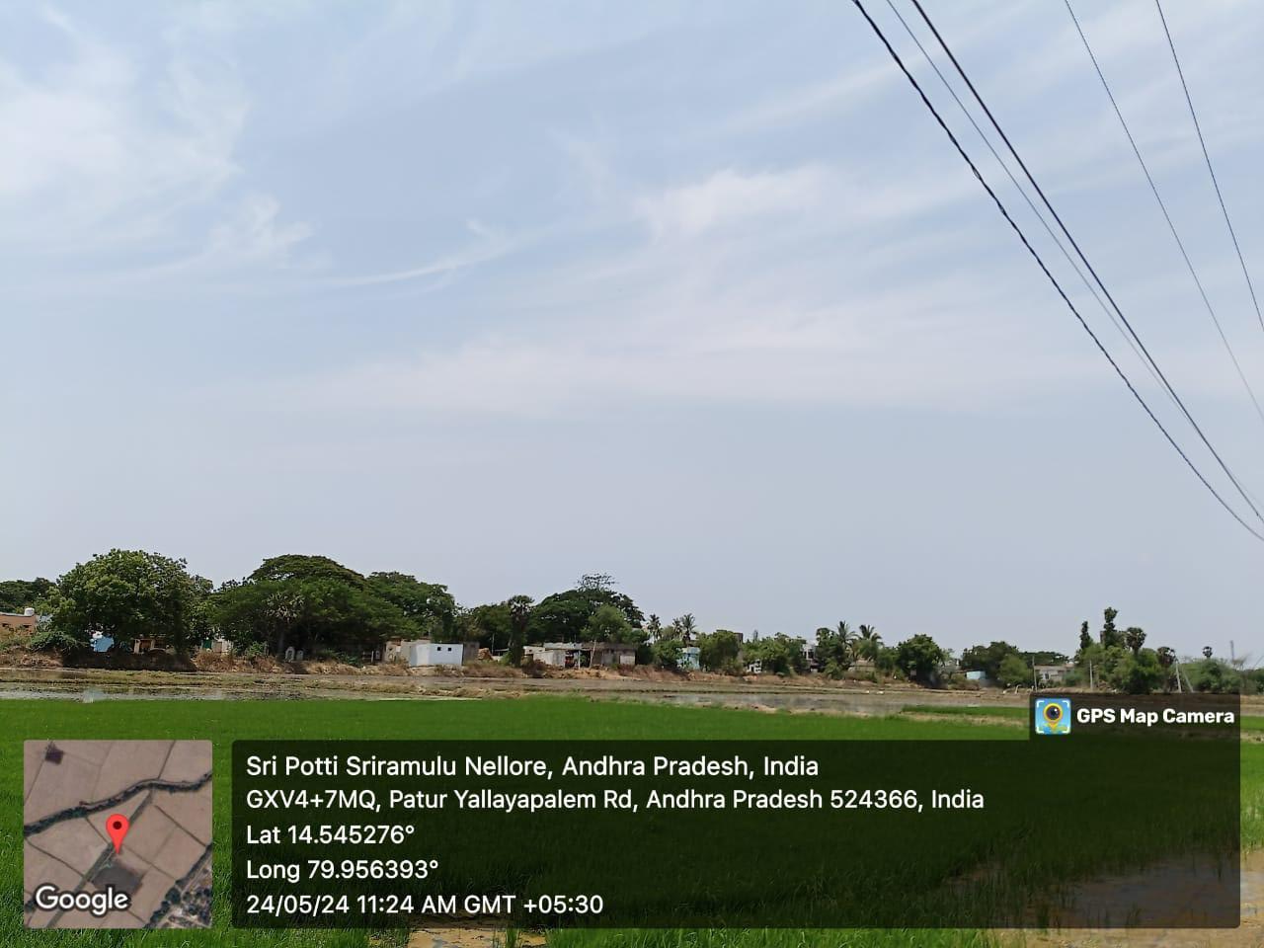

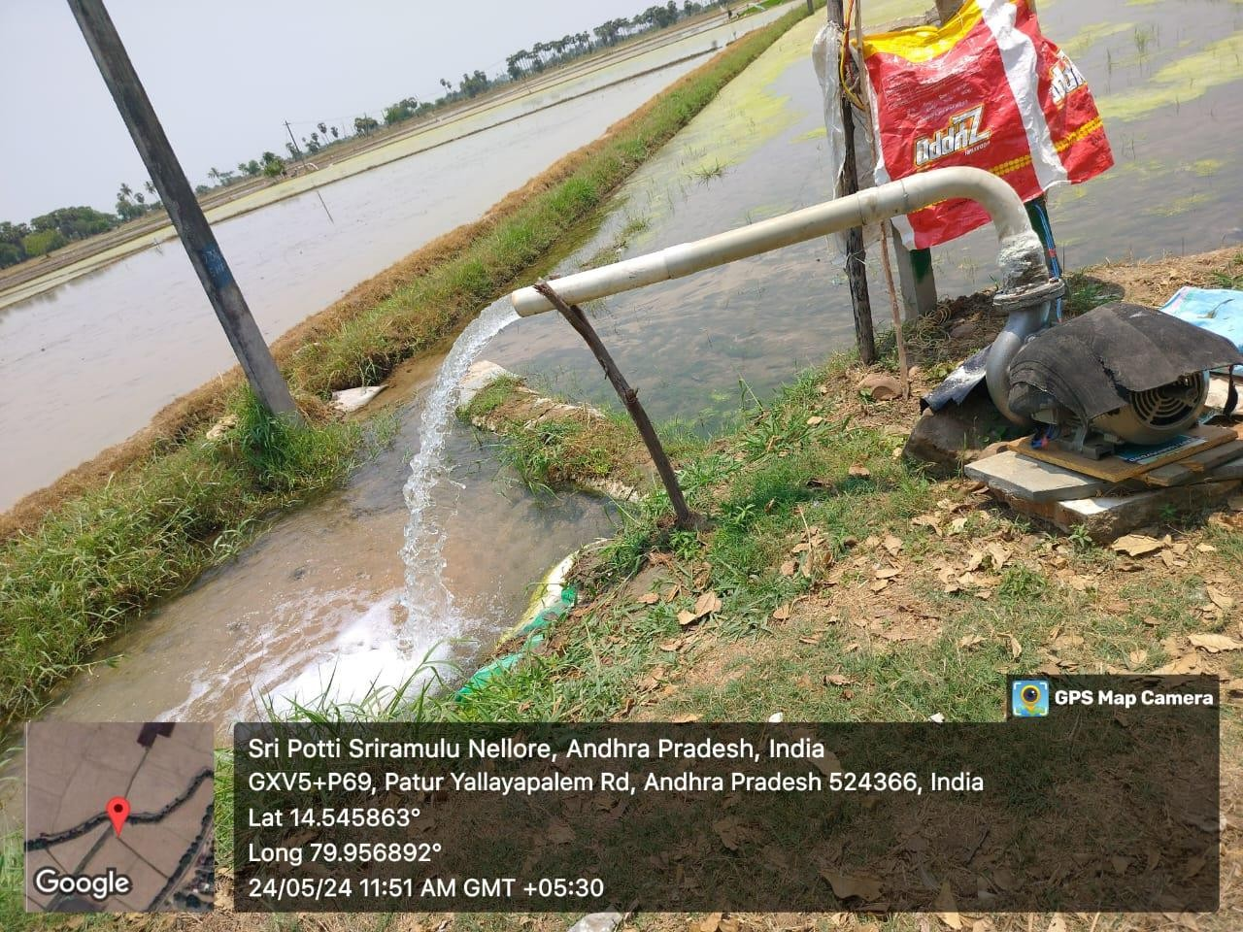

*Motors in Village Rajupalem*

**ACTIVITY LOG FOR THIRD WEEK**

|  |  |  |  |
| --- | --- | --- | --- |
| **DAY**  **& DATE** | **BRIEF DESCRIPTION OF THE DAILY ACTIVITY** | **LEARNING OUTCOME** | **Person**  **In-charge**  **Signature** |
| Day-1 | Visiting a village | We visited Mypadu(4th mile), Nellore district to interact with people to know more. |  |
| Day-2 | Introduction to Solar panels and cost of a Solar panel | Solar panel systems can bring many advantages to rural villages, including **improved access to electricity, reduced energy costs, and economic opportunities.**  The average cost of a solar panel in the  U.S. ranges  between **$17,350** and **$38,000**, depending on location. |  |
| Day-3 | Advantages of Solar panels | * Reduction of Electricity Bills * Low Maintenance * Environmentally Friendly * Job Creation |  |
| Day-4 | Crops grown under Solar panels | -Leafy green vegetables like cabbage and broccoli  -Berries like strawberries, blueberries  -Root vegetables |  |
| Day-5 | Factors influencing Solar panels | >Climatic conditions  >Location and orientation  >Temperature  >Weather conditions  >Inverter efficiency |  |
| Day-6 | Conclusion | We finally understood about solar panels by interacting more we known about what crop can be cultivated and advantages of solar panels. |  |

**WEEKLY REPORT**

**Week-3 (From dt: 27-05-2024 to dt: 01-06-2024**)

|  |
| --- |
| **Objective of the Activity Done: Utilization of free electricity to farmers and related issues***.* |
| **Detailed Report:** |
| On day-1:   * On this day our team visited 4th mile in the Nellore district and conducted survey. * The fields growing here are very vast in area and greenery finds everywhere. * And started asking people about their way of growing. |
| On day-2:   * After conversation with farmers, we came to know that solar panels systems are somewhere used. * Farmers can generate electricity for their own purposes i.e., water motors. * Average cost ranges from Rs.35,000 to Rs.55,000 for installation. |
| On day-3:   * We questioned them what advantages are by solar panels. * We understand that it reduces electricity usage, eco-friendly, easy maintenance. |
| On day-4:   * We asked what type of crops are grown by using solar panels. * They said,” We grow leafy vegetables, cabbage, root vegetables.” |
| On day-5:   * We surveyed about factors that influence solar is: * Climatic conditions, temperature, weather conditions, location. * We came to conclusion of usage of solar panels and profit for the farmers |
| On day-6:   * We finally understood that, the working of solar panels, their cost and type of crops grown and factors. * And finally, we submitted this week report to our respected guide. |

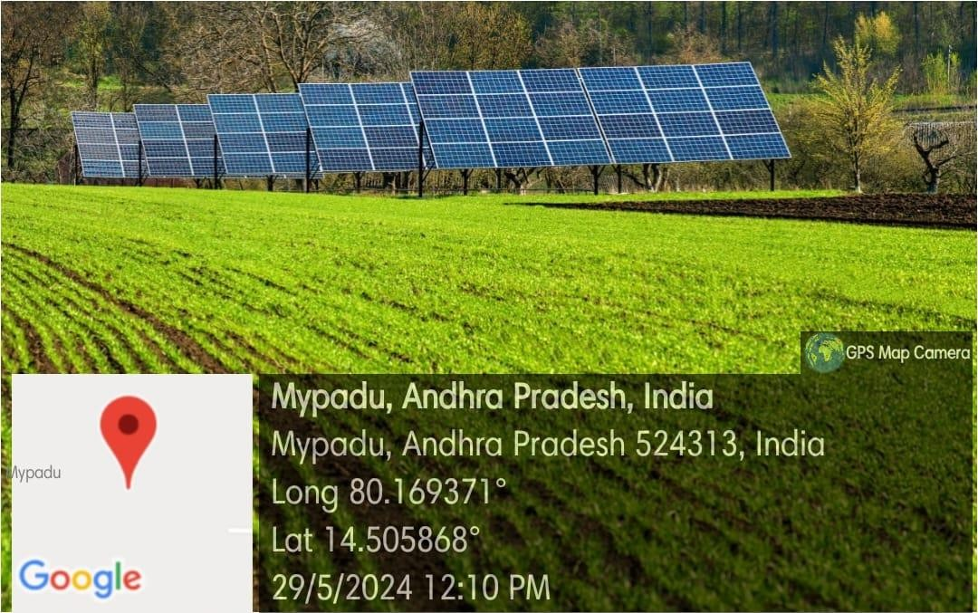

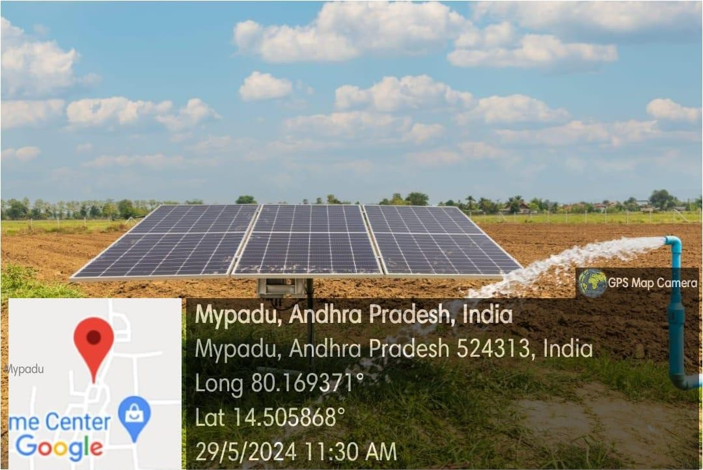

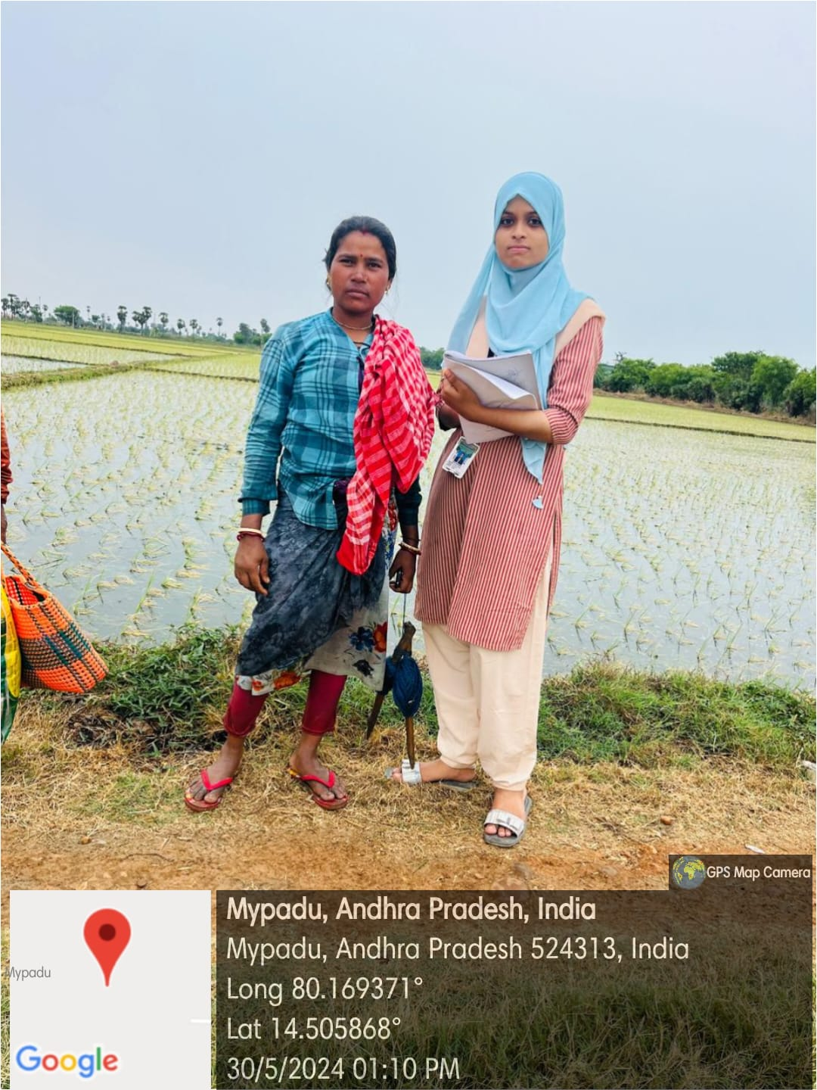

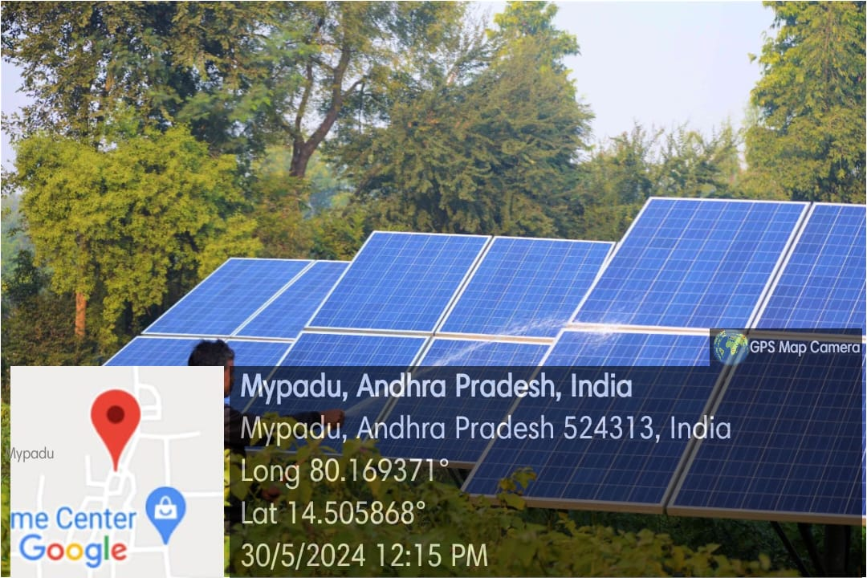*Solar panels*

**ACTIVITY LOG FOR FOURTH WEEK**

|  |  |  |  |
| --- | --- | --- | --- |
| **DAY & DATE** | **BRIEF DESCRIPTION OF THE DAILY ACTIVITY** | **LEARNING OUTCOME** | **Person In-charge Signature** |
| Day-1 | What is Drip irrigation? | Drip irrigation, also known as trickle irrigation or micro-irrigation, is a **precision water delivery system** designed to save water and nutrients. |  |
| Day-2 | How does Drip irrigation work? | It works based on few categories:  >Tubing and emitters  >Efficient water use  >Crop types  >Water source |  |
| Day-3 | What are the advantages of using Drip irrigation? | ✧Increased plant health  ✧Money savings  ✧Energy savings  ✧Water conservation and efficiency |  |
| Day-4 | What are the disadvantages of Drip irrigation? | >Direct sunlight reduces lifespan of tubes.  >Affects soil fertility  >Root growth restriction  >Improper filtration may cause clogging |  |
| Day-5 | Types of Drip irrigation? | ✧Point source emitter system  ✧Inline drip system  ✧Subsurface drip system  ✧Drip tape system  ✧Micro-sprinkler system |  |
| Day-6 | What types of crops are best suited for Drip irrigation? | >Vegetables: Tomato, Onion, Bitter gourd  >Cash crops: Sugar cane, Cotton  >Orchard crops: Grapes, Banana, pomegranate, Citrus |  |

**WEEKLY REPORT**

**Week-4 (From dt: 03-06-2024 to dt: 08-06-2024)**

|  |
| --- |
| **Objective of the Activity Done: Utilization of free electricity to farmers and related issues***.* |
| **Detailed Report:** |
| On day-1:   * On the day of our survey, we got to know an irrigation method called ‘Drip irrigation’. * We prepared survey questionnaire, and initial questions on drip irrigation. |
| On day-2:   * We learnt how drip irrigation works. It works based on many categories. * Some are tubing and emitters, water source, crop types. * In this method, water is supplied directly through roots. |
| On day-3:   * After knowing all these, we surveyed abut its advantages. * Like- Energy savings, increased plant health, money savings. |
| On day-4:   * All can’t be good, so we surveyed also about its disadvantages. * It reduces life span of tube due to direct sunlight, sometimes water may not be distributed evenly to crops. |
| On day-5:   * Drip irrigation includes in different types for different crops and farming practices. * Micro sprinkler for large areas, Inline drip for row crops and gardens, subsurface drip for crops that grow under surface. |
| On day-6:   * At last we are interested in knowing which crops are growing under this system. * They are vegetables like tomato, onion. Cash crops like sugarcane, cotton and more like grapes, banana, etc. |

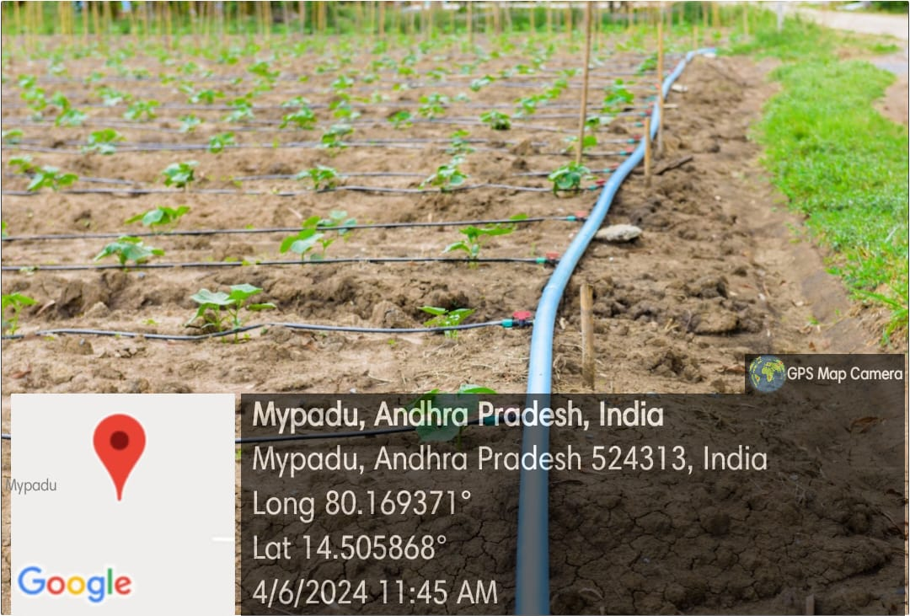

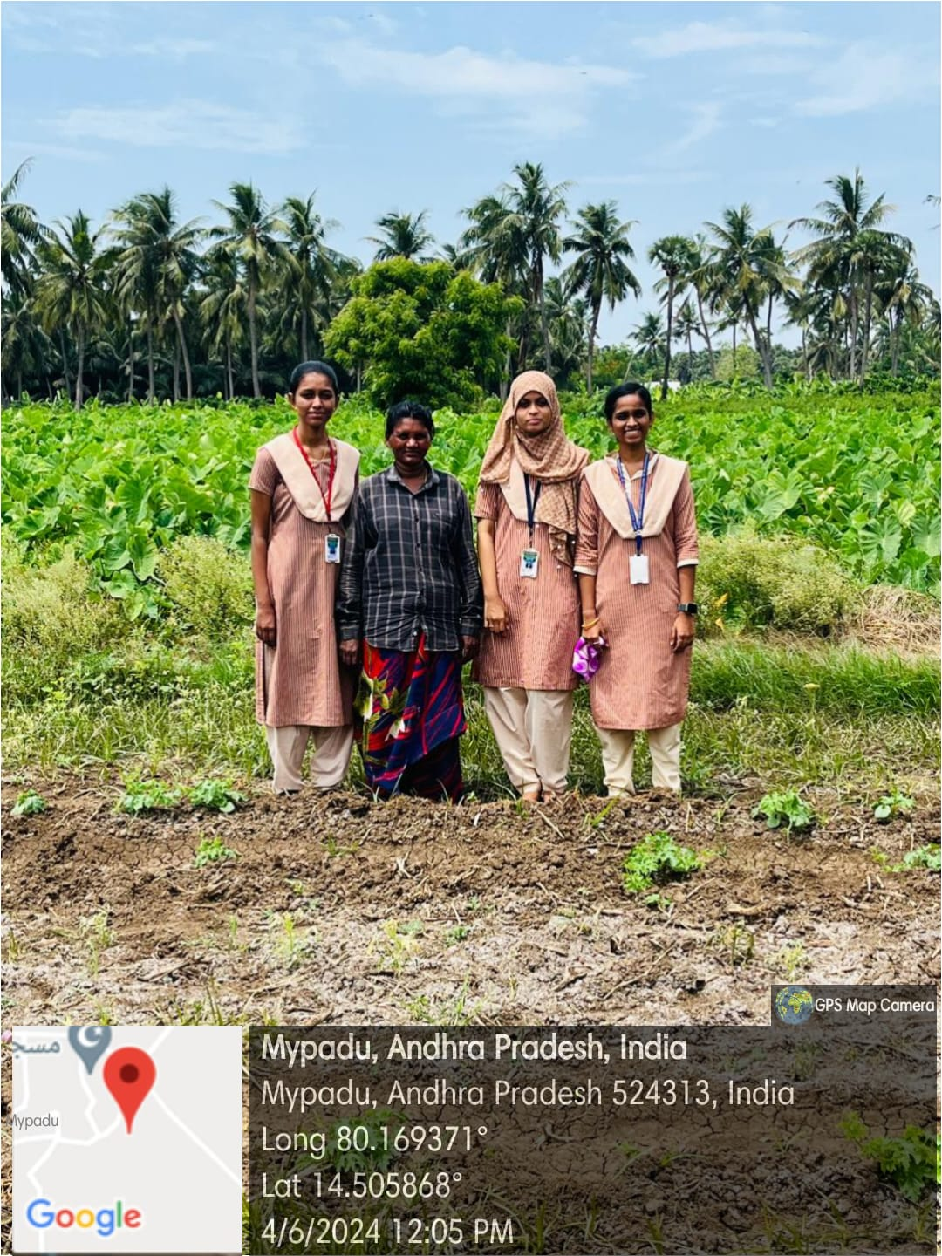

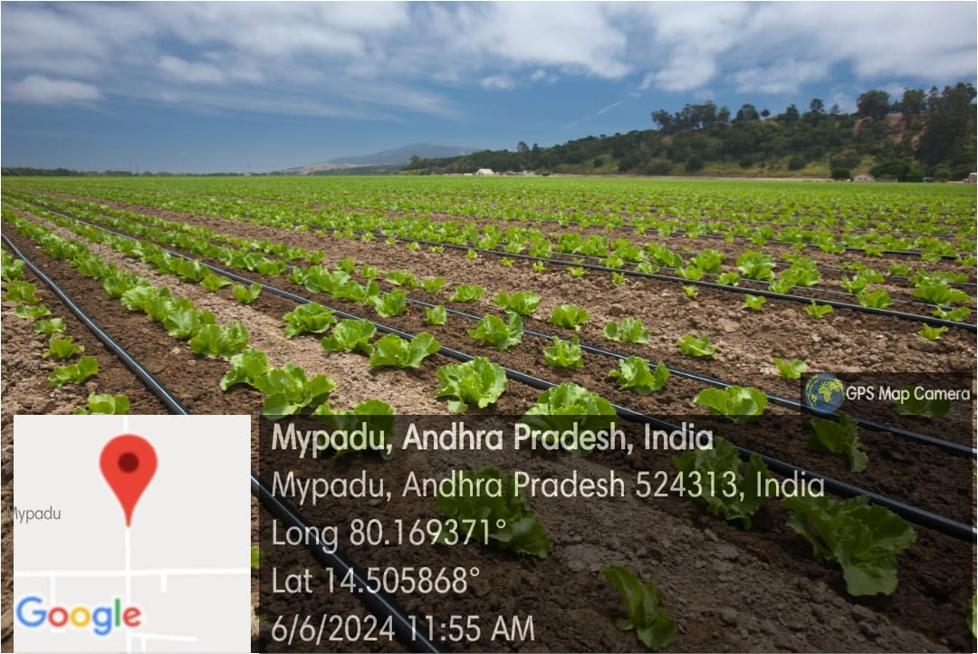

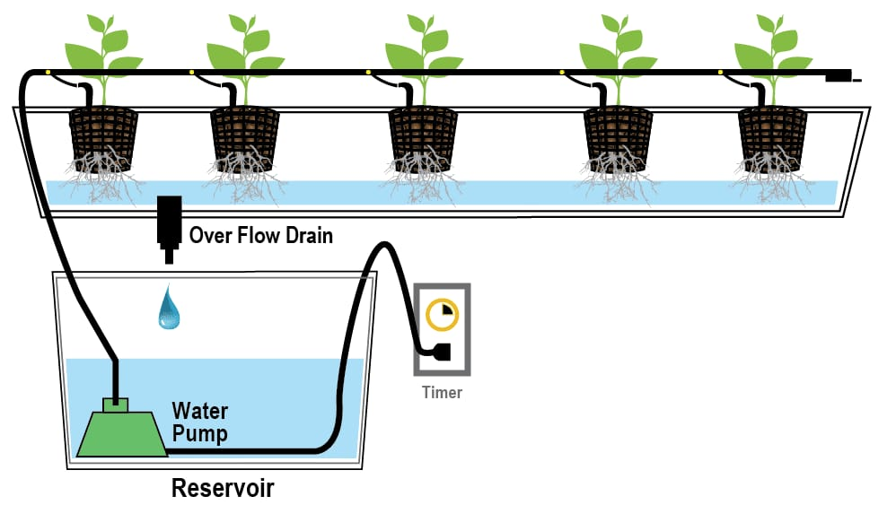

***Drip irrigation system***

**ACTIVITY LOG FOR FIFTH WEEK**

|  |  |  |  |
| --- | --- | --- | --- |
| **DAY &**  **DATE** | **BRIEF DESCRIPTION OF THE DAILY ACTIVITY** | **LEARNING OUTCOME** | **Person In-charge Signature** |
| Day-1 | Introduction to Sprinkle irrigation | An **i**rrigation sprinkler (also known as a water sprinkler or simply a sprinkler) is a device used to irrigate (water) agricultural crops, lawns, landscapes, golf courses, and other areas. |  |
| Day-2 | Types of Sprinkle irrigation | >Portable sprinkler irrigation  >Solid set and permanent sprinkler irrigation  >Side roll sprinkler irrigation  >Wheel line sprinkler irrigation |  |
| Day-3 | What are the advantages of using Sprinkle irrigation? | - Less infestation of pests and  Diseases.  -Reduced water usage and labor costs.  -Increase in crop yields and healthy growth of crops. |  |
| Day-4 | What are the disadvantages of Sprinkle irrigation? | >High operating cost  >Water will drift when there is a lot of wind  >A stable water supply is needed  >Saline water may cause problem |  |
| Day-5 | What types of crops are best suited for Sprinkle irrigation? | >Vegetables such as potatoes, corn, soyabeans  >Grains such as wheat, oats  >Fruits such as grapes, citrus fruits, stone fruits |  |
| Day-6 | How much time they use electricity for Sprinkle irrigation? | On average, a sprinkler system uses around **1,200 watts per hour.** |  |

**WEEKLY REPORT**

**Week-5 (From dt: 10-06-2024 to dt: 15-06-2024)**

|  |
| --- |
| **Objective of the Activity Done: Utilization of free electricity to farmers and related issues***.* |
| **Detailed Report:** |
| On day-1:   * On this day of our survey, we also observed another type of irrigation method called “Sprinkle irrigation”. * It is a water sprinkler device used to irrigate landscapes, crops through pipes and sprinklers. * Water is pumped through the pipes and distributed by the sprinklers over the irrigation area. |
| On day-2:   * We surveyed about the types of sprinkle irrigation used in different conditions. * Centre pivot for large scale agriculture, micro sprinkler for small areas, and lateral pivot for rectangular areas. |
| On day-3:   * The advantages we came to know are water is uniformly distributed, flexibility in soil, and saves more time and labour cost. * Due to these advantages in further this system may increase more and reduce manual working. |
| On day-4:   * Including advantages also there are disadvantages using this system. * There is water loss, high cost for installation and maintenance, and large energy consumption is required. |
| On day-5:   * We observed the crops grown under this system and started surveying about the crops grown. * They grow cereals like wheat, vegetables like carrots, and others. |
| On day-6:   * At last we asked them about how much electricity is used for this system. * Based on the size of the area the usage of electricity is required. * On average it consumes 1200 watts per hour and it runs averagely 30-60 min per zone. |

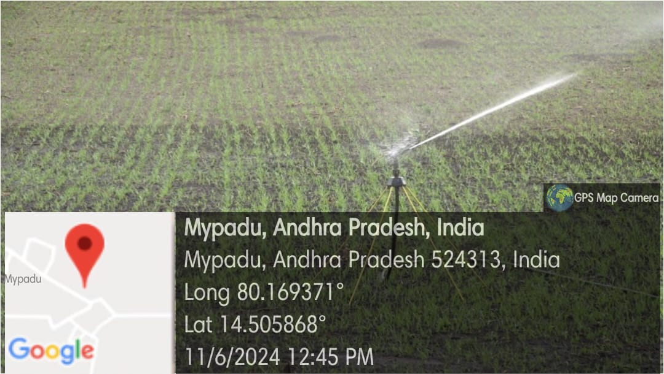

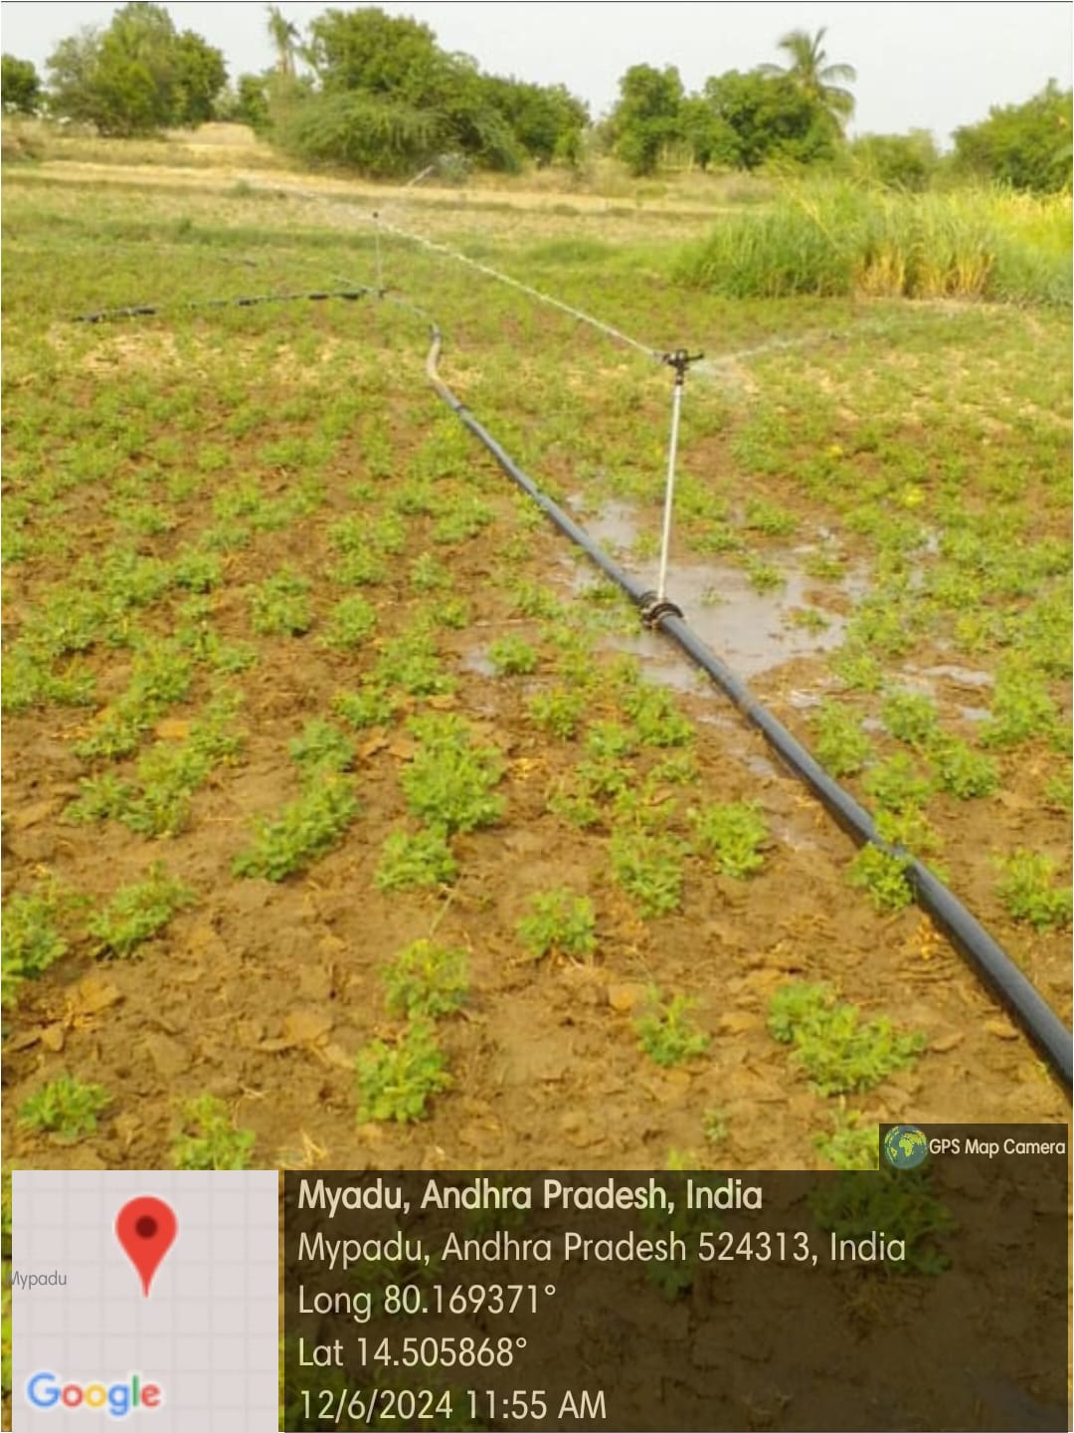

**ACTIVITY LOG FOR SIXTH WEEK**

|  |  |  |  |
| --- | --- | --- | --- |
| **DAY**  **& DATE** | **BRIEF DESCRIPTION OF THE DAILY ACTIVITY** | **LEARNING OUTCOME** | **Person In-charge Signature** |
| Day-1 | How essential is electricity to farming activities? | Electricity plays a key role in the agricultural sector as it is used for powering a wide range of equipment and systems that facilitate production. Electric pumps are used to supply the water for irrigation and lighting for the crops. |  |
| Day-2 | Who started giving free electricity to farmers in India and Andhra Pradesh? | In India, Prime minister Narendra Modi started giving free electricity to farmers on February 15,2024.  In AP, Dr. Y. S. Rajashekhar Reddy started giving free electricity to farmers. |  |
| Day-3 | Which irrigation is best in between Drip and sprinkle irrigation? Which consumers less electricity in between them? | Between drip irrigation and sprinkler irrigation, the choice depends on various factors including crop type, soil type, climate, and water availability. However, regarding electricity consumption, drip irrigation generally consumes less electricity compared to sprinkler irrigation |  |
| Day-4 | How much electricity a farmer consumes per a day in India? | On average, an Indian village has a total electricity demand of approximately 1,826 kWh per day. |  |
| Day-5 | What is the average electricity bill in farming per day? | On an average a farmer gets 210 rupees as an electricity bill per day. |  |
| Day-6 | What will be the impact on villages if there is no electricity? | The impact on villages without electricity can be significant and wide-ranging, affecting various aspects of daily life and development: such as Quality of life, Education, Economic development, connection and connectivity etc |  |

**WEEKLY REPORT**

**Week-6 (From DT: 17-06-2024 to DT: 22-06-2024)**

|  |
| --- |
| **Objective of the Activity Done: Utilization of free electricity to farmers and related issues***.* |
| **Detailed Report:** |
| On day-1:   * After surveying all about sources of electricity used by farmers, this day we surveyed about how electricity is essential to farmers, and who started this scheme, etc. * We understood that electricity plays a key role and widely used. * Mostly water motors are used more under electricity usage. |
| On day-2:   * During our survey we wanted to know how, when and by whom this scheme was started. * We came to know that, in India Prime minister Narendra Modi started giving free electricity to farmers on February 15, 2024. * In AP, Dr. Y. S. Rajashekhar Reddy started giving free electricity to farmers. |
| On day-3:   * Regarding the usage of electricity we compared the use of electricity in drip and sprinkle irrigations. * Both are used based on the fertility of land, crops, and water availability. * While during electricity drip consumes less electricity compared to sprinkle irrigation. |
| On day-4:   * We gathered overall usage of electricity in India through online. * An Indian village has a total electricity demand of approximately 1,826 kWh per day. * In Andhra Pradesh they consume averagely 17,905 MW. |
| On day-5:   * We researched on how much electricity bill farmers get per day for irrigation. * On an average a farmer gets 210 rupees as an electricity bill per day. |
| On day-6:   * We ourselves questioned, what if there will be no electricity for farming. * Electricity in farming developed the amount of crops, save time and make connectivity outside world. * At final we completed this week report and submitted it to our respected guide. |

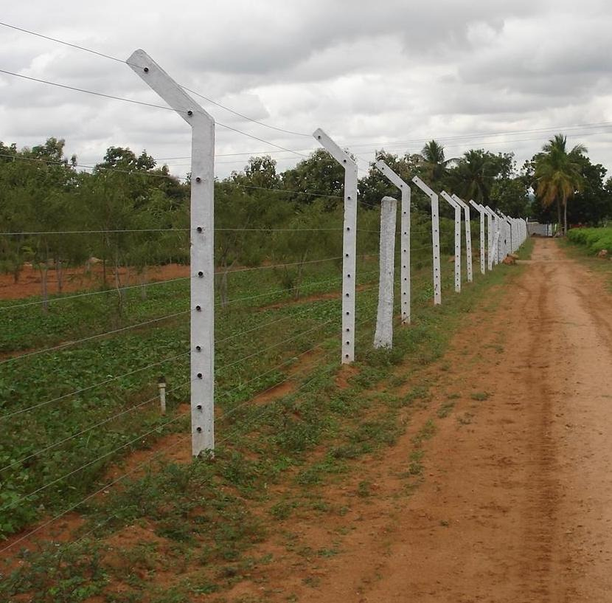 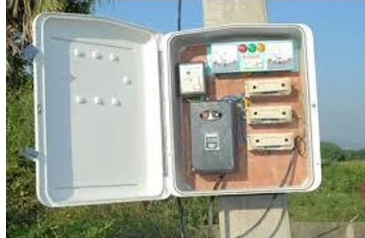

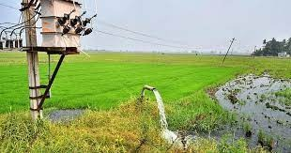

CHAPTER 5: OUTCOMES DESCRIPTION

Details of the Socio-Economic Survey of the Village/Habitation. Attach the questionnaire prepared for the survey:

We have conducted a socio-economic survey of a village focusing on the utilization of free electricity and related issues. This essay outlines the key areas of our survey, highlighting the demographic, economic, and electricity usage patterns, as well as the challenges faced by residents.

Economic Status:

In assessing the economic status of the village, we examined the primary sources of income, which typically included agriculture, employment, business, and daily wages.

Electricity Usage:

Electricity availability and usage patterns were critical components of our survey. We determined the hours of electricity supply per day and its reliability. We also identified the various sources of electricity, such as grid electricity, solar power, or generators, indicating the level of energy infrastructure development.

Free Electricity Utilization:

We identified the number of households availing these schemes and examined how they utilized the free electricity. Common uses included lighting, powering household appliances, irrigation, and other productive activities that enhance living standards.

Conclusion:

Having conducted this socio-economic survey of the village focusing on the utilization of free electricity and related issues, we gained a nuanced understanding of the benefits and challenges associated with such initiatives.

Another critical issue was the sustainability of free electricity schemes. Dependence on free electricity without proper planning for future infrastructure development can lead to long-term problems.

Questionnaire prepared for the survey:

1. What is the usage of electricity in farming?

2. What is the usage of electricity in a day?

3. What is the importance of electricity for a particular crop?

4. How significant a role does electricity play in farming?

5. What are solar panels, and what is their average cost?

6. What are the advantages of solar panels?

7. Is it possible to grow crops under solar panels, and if so, which ones?

8. What are the factors influencing solar panels?

9. What is drip irrigation, and how does it work?

10. What are the advantages of using drip irrigation?

11. What are the disadvantages of using drip irrigation?

12. What are the different types of drip irrigation systems available?

13. What types of crops are best suited for Drip irrigation?

14. What is sprinkle irrigation?

15. What are the different types of sprinklers used in sprinkle irrigation?

16. What are the advantages of using Sprinkle irrigation?

17. What are the disadvantages of using Sprinkle irrigation?

18. What types of crops are best suited for Sprinkle irrigation?

19. How many hours a day does a typical sprinkle irrigation system use electricity?

20. How essential is electricity to farming activities?

21. Who started giving free electricity to farmers in India and Andhra Pradesh?

22. Which irrigation is best in between Drip and sprinkle irrigation? Which consumers less electricity in between them?

23. How much electricity a farmer consumes per a day in India?

24. What is the average electricity bill in farming per day?

25. What will be the impact on villages if there is no electricity?

Describe the problems you have identified in the community:

Problems faced by farmers:

1. Unreliable power supply: Frequent outages and voltage fluctuations affect farm operations and equipment.

2. High energy costs: Electricity expenses can be a significant burden, especially for small-scale farmers.

3. Limited access to grid electricity: Rural areas often have inadequate or no grid connectivity, making it difficult for farmers to access electricity.

4. Inefficient irrigation systems: Outdated or poorly maintained irrigation systems lead to energy waste and reduced crop yields.

5. Equipment maintenance: Farmers often struggle with maintenance and repair of electric-powered equipment due to limited resources and expertise.

6. Limited access to credit: Farmers may find it challenging to secure financing for electrical infrastructure upgrades or equipment purchases.

7. Climate change and extreme weather events: Farmers face increasing challenges due to climate-related disruptions, such as droughts or floods, which can impact electricity availability and farm operations.

Farmers face various challenges related to electricity usage, including:

8. Lack of training: Farmers may need guidance on efficient electricity use and modern farming technologies.

9. Safety concerns: Farmers may be exposed to electrical hazards due to improper wiring, outdated infrastructure, or inadequate safety measures.

10. Technological barriers: Farmers may struggle to adopt new technologies, such as precision agriculture and renewable energy systems, due to limited knowledge and resources.

Short-term and long term action plan for possible solutions for the problems identified and that could be recommended to the concerned authorities for implementation:

Short-term actions:

1. Provide training and workshops on efficient electricity use and safety practices.

2. Offer subsidies or incentives for farmers to invest in energy-efficient equipment and technologies.

3. Conduct energy audits to identify areas of improvement in farm operations.

4. Establish mobile repair services for electric-powered equipment.

5. Develop financing options for farmers to access capital for electrical infrastructure upgrades.

6. Implement temporary solutions for unreliable power supply, such as generators or solar-powered systems.

7. Create awareness campaigns to promote energy-efficient practices and technologies.

8. Collaborate with agricultural extension services to provide on-field support.

Long-term actions:

1. Develop and implement rural electrification plans to expand grid connectivity.

2. Invest in renewable energy sources, such as solar, wind, or biogas, to reduce dependence on grid electricity.

3. Promote precision agriculture and automation technologies to optimize energy use.

4. Establish farmer cooperatives or collectives to share resources and expertise.

5. Develop and deploy energy-efficient irrigation systems and water management practices.

6. Implement smart grid technologies to manage energy distribution and consumption efficiently.

7. Develop financing models for farmers to access capital for long-term electrical infrastructure upgrades.

8. Establish research and development centers to develop new technologies and solutions tailored to farmers' needs.

Description of the Community awareness programme/s conducted w.r.t the problems and their outcomes:

Community awareness programs were conducted to educate farmers on efficient electricity use, safety practices, and benefits of renewable energy sources. The programs included:

>Workshops and seminars: Interactive sessions with farmers, experts, and technicians to discuss energy-efficient practices, safety measures, and new technologies.

Outcome: Increased awareness and adoption of energy-efficient practices, reduced energy waste, and improved safety.

> Demonstrations and exhibitions: Showcasing energy-efficient equipment, renewable energy systems, and precision agriculture technologies.

Outcome: Increased interest and investment in energy-efficient technologies and renewable energy sources.

> Training and capacity building: Hands-on training for farmers and technicians on installation, maintenance, and repair of energy-efficient equipment.

Outcome: Improved technical skills and confidence among farmers and technicians.

>Awareness campaigns: Posters, pamphlets, and social media campaigns to reach a wider audience.

Outcome: Increased awareness and engagement among farmers, their families, and the broader community.

>Farmer-to-farmer learning: Encouraging experienced farmers to share their knowledge and best practices with peers.

Outcome: Peer-to-peer learning, increased adoption of energy-efficient practices, and strengthened community bonds.

>Collaborations and partnerships: Partnerships with agricultural extension services, research institutions, and private companies to leverage resources and expertise.

Outcome: Access to expertise, technology, and funding, leading to improved outcomes and sustainability.

These community awareness programs led to:

- Improved energy efficiency and reduced energy waste

- Increased adoption of renewable energy sources

- Enhanced safety practices and reduced electrical hazards

- Increased awareness and engagement among farmers and the broader community

- Strengthened partnerships and collaborations

- Improved agricultural productivity and sustainability

MINI PROJECT

(From 20-06-2024 to 04-07-2024)

Title of the Project: A webpage designed on “Utilization of electricity to farmers and related issues"

Report of the Mini-project work done in the related subject w.r.t the habitation/village:

Over the past six weeks I participated in a community service project focused on utilization of electricity to farmers. our goal was to promote utilization of electricity and educate the community about the benefits of using efficient electricity in farming. Through hands-on experiences and guided leraning, we explored various aspects of using electricity in farming such as solar panels, sprinkle irrigation, drip irrigation, and electric motors. During the project, we conducted a site assessment and developed a detail plan for effective execution. We learned about the importance of electricity in agriculture.

As a part of our community service project we went to rajupalem village. Rajupalem is a small village where there are many crops. In rajupalem, we found more related information about our community service project. We went to nearby places in rajupalem, we interacted with farmers about the usage of electricity in there farming. Farmers utilize electricity in various ways to enhance their agricultural productivity and efficiency. They use electricity to power irrigation systems, lighting for farm buildings and outdoor areas, and machinery like tractors and harvesters. Additionally, electricity enables refrigeration for storing perishable produce and dairy products, automation of farm processes like feeding and milking, and water management systems for efficient water distribution. Furthermore, electricity facilitates communication through phones, radios, and internet connectivity, allowing farmers to access market information and manage their operations effectively. Finally, electricity powers value-added activities like sorting, grading, and packaging of farm produce, helping farmers to increase their income and competitiveness. By leveraging electricity in these ways, farmers can improve their overall productivity, reduce costs, and contribute to sustainable agricultural development.

Main objectives :

The main objectives of utilizing electricity by farmers are:

1. Improved irrigation management: Electricity powers irrigation systems, enabling efficient water distribution and reduced labor.

2. Enhanced farm productivity: Electricity-powered machinery and equipment increase farm productivity and reduce manual labor.

3. Better lighting and safety: Electricity provides lighting for farm buildings and outdoor areas, ensuring safety and security.

4. Effective water management: Electricity powers water treatment, pumping, and distribution systems, ensuring optimal water use.

5. Increased efficiency in farm processes: Electricity automates tasks like feeding, milking, and egg collection, reducing labor and improving efficiency.

6. Improved produce storage and preservation: Electricity powers refrigeration systems, enabling farmers to store perishable produce and dairy products effectively.

7. Enhanced communication and market access: Electricity facilitates communication through phones, radios, and internet connectivity, connecting farmers to markets and essential services.

8. Value addition and income growth: Electricity powers processing and value-added activities, enabling farmers to increase their income and competitiveness.

Introduction:

Electricity is a vital input in modern agriculture, transforming the way farmers cultivate, produce, and market their crops. The utilization of electricity by farmers has revolutionized agricultural practices, increasing efficiency, productivity, and profitability. With electricity, farmers can power essential systems and equipment, such as irrigation pumps, lighting, machinery, and communication tools. This enables them to:

- Enhance crop yields and quality

- Reduce labor and energy costs

- Improve farm safety and security

- Access market information and services

- Increase value addition and income

The effective use of electricity in agriculture is crucial for sustainable farming practices, food security, and rural development. In this context, we will explore the various aspects of electricity utilization by farmers, including its benefits, challenges, and future directions.

Moreover, electricity facilitates farm-to-market connectivity, enabling farmers to access vital information, market services, and value-added processing and packaging capabilities. This connectivity also enables farmers to participate in e-commerce platforms, expanding their market reach and improving their income. Furthermore, the adoption of renewable energy sources, like solar and biogas, is increasingly being adopted by farmers to power their operations, reducing reliance on grid electricity and mitigating climate change impacts. Overall, the strategic use of electricity in agriculture is critical for sustainable farming practices, rural development, and ensuring global food security.

Benefits:

1. Increased efficiency: Electricity-powered equipment and automation reduce labor and energy costs.

2. Improved crop yields: Electricity-powered irrigation, lighting, and heating/cooling systems enhance crop growth and quality.

3. Enhanced safety: Electricity-powered lighting and security systems improve farm safety and security.

4. Access to information: Electricity-powered communication tools connect farmers to market information, weather updates, and agricultural expertise.

5. Value addition: Electricity-powered processing and packaging equipment enable farmers to add value to their produce.

Challenges:

1. Access to electricity: Many rural areas lack reliable electricity supply, hindering farmers' ability to adopt electricity-dependent technologies.

2. Cost: Electricity can be expensive, especially for small-scale farmers.

3. Maintenance: Electricity-powered equipment requires regular maintenance, which can be time-consuming and costly.

4. Grid reliability: Frequent power outages can disrupt farm operations and damage equipment.

Future directions:

1. Renewable energy: Farmers are increasingly adopting solar, wind, and biogas energy sources to reduce reliance on grid electricity.

2. Energy efficiency: Farmers are adopting energy-efficient equipment and practices to minimize energy consumption.

3. Smart agriculture: Electricity-powered precision agriculture technologies, such as drones and sensors, optimize crop management and reduce waste.

4. Rural electrification: Governments and organizations are working to expand electricity access to rural areas, promoting agricultural development.

By understanding these aspects, we can better appreciate the critical role electricity plays in modern agriculture and work towards sustainable and efficient farming practices.

General principles:

1. Reliability: Electricity supply should be reliable and consistent to ensure uninterrupted farm operations.

2. Safety: Electrical installations and equipment should be installed and maintained to ensure the safety of people and animals.

3. Cost-effectiveness: Farmers should optimize energy use to reduce costs and improve profitability.

4. Sustainability: Farmers should consider using renewable energy sources like solar, wind, and biogas to reduce their carbon footprint.

5. Productivity: Electricity should be used to enhance farm productivity, quality, and yield.

6. Innovation: Farmers should stay updated on new technologies and innovations in electrical equipment and practices.

7. Training: Farmers should receive training on safe and effective use of electrical equipment and technologies.

8. Grid connection: Farmers should explore opportunities to connect to the grid or mini-grids to access stable and reliable electricity supply.

USES OF ELECTRICITY IN VILLAGES:

Electricity can be used in many aspects like:

* Electric Motors
* Drip irrigation
* Sprinke irrigation
* Solar Panels

Electric motors**:**

Electric motors are used in agriculture for:

- Irrigation systems and lighting: Electric pumps are used for irrigation and lighting of crops to increase growth and productivity.

- Electric fencing: Electric fencing is used to protect crops from pests and for animal control.

- Plowing, tilling, and harvesting: Electric motors are used to power machines for plowing tilling, and harvesting crops.

- Automatic farm equipment: Electric motors are used to power automatic feeders, spreaders, and harvesters.

- Electric tools: Electric tools such as lawn mowers, weeders, pruners, and harvesters are used to automate various tasks within the farm.

- Tractors: Electric tractors are used for planting and tilling with pinpoint accuracy and for fertilizer delivery.

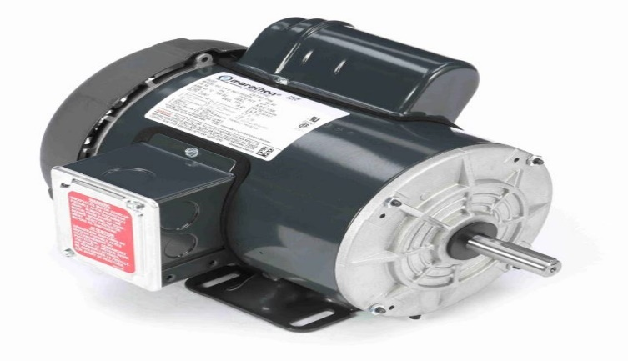

Drip Irrigation:

Drip irrigation, also known as trickle irrigation, is a method of irrigation that saves water and increases crop yields by delivering water directly to the roots of plants, drop by drop. Its usage in agriculture includes:

1. Water conservation: Reduces water evaporation and runoff, saving up to 70% of water compared to traditional flood irrigation.

2. Increased crop yields: Plants receive exact amounts of water, promoting healthy growth and higher yields.

3. Reduced soil erosion: Water is applied slowly, reducing soil erosion and nutrient loss.

4. Improved crop quality: Drip irrigation helps maintain optimal soil moisture, leading to better crop quality.

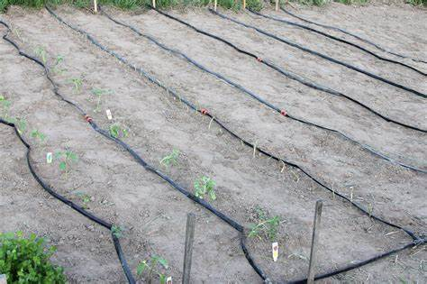 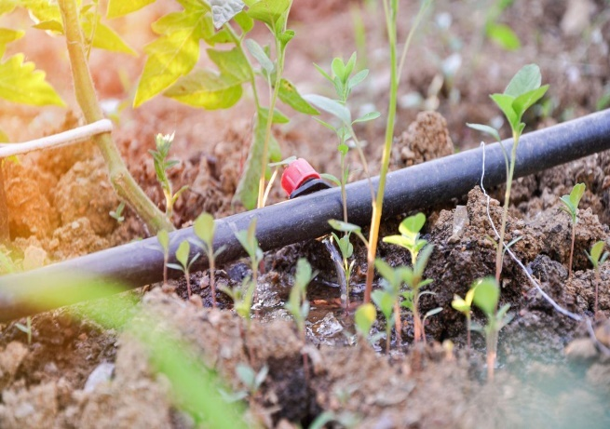

Sprinkle irrigation:

Sprinkle irrigation, also known as sprinkler irrigation, is a method of irrigation that distributes water over the soil surface through a network of pipes and sprinklers, simulating natural rainfall. Its usage in agriculture includes:

1. Uniform water distribution: Sprinklers distribute water evenly, ensuring all plants receive equal amounts.

2. Water conservation: Sprinkle irrigation reduces water loss due to evaporation and runoff.

3. Increased crop yields: Proper water distribution promotes healthy growth and higher yields.

4. Reduced soil erosion: Water is applied gently, reducing soil erosion and nutrient loss.

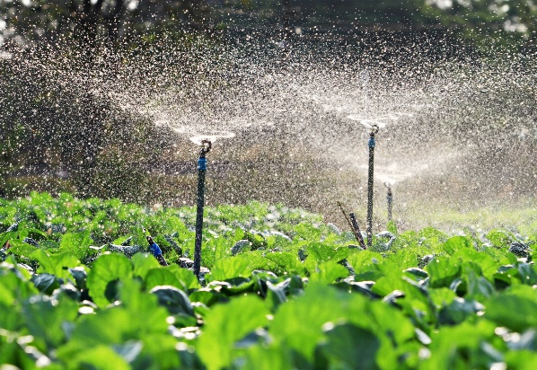 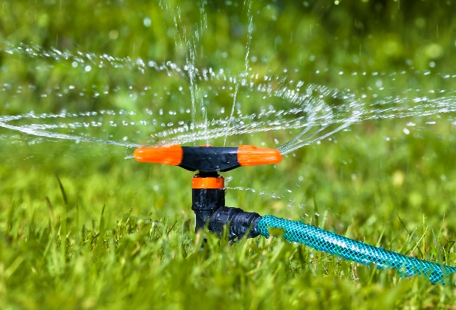

Solar Panels:

Here are some uses and benefits of solar panels in agriculture:

1.Sustainability: Solar panels reduce carbon footprint by harnessing sunlight and converting it into energy.

2.Cost-Efficiency: Solar panels reduce operational costs by providing a cheaper alternative to electricity and diesel.

3.Energy Independence: Solar panels provide a reliable source of energy and reduce dependence on erratic power grids.

4.Solar Agri-feeders: Solar panels can be used to power agri-feeders, reducing operational costs and ensuring the welfare of livestock.

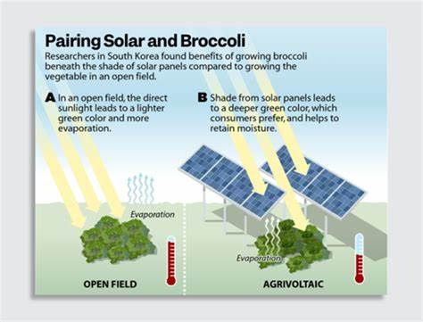 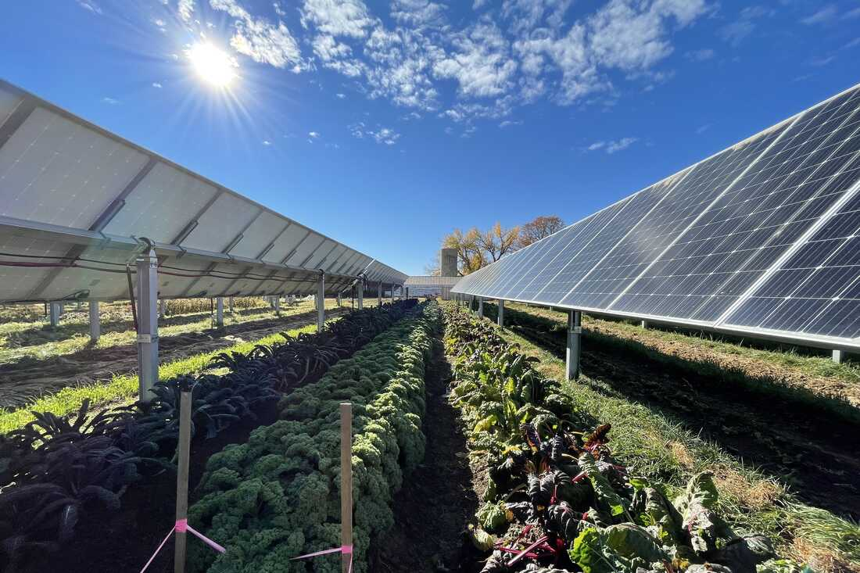

CHAPTER-6

RECOMMENDATIONS AND CONCLUSIONS OF THE MINI PROJECT:

RECOMMENDATIONS:

1. Conduct an energy audit to identify areas of energy inefficiency and opportunities for improvement.

2. Install energy-efficient lighting and equipment, such as LED bulbs and motor controls.

3. Use renewable energy sources like solar, wind, or biogas to reduce reliance on grid electricity.

4. Implement precision agriculture technologies like drones, sensors, and automation to optimize crop management and reduce energy waste.

5. Optimize irrigation systems using timers, sensors, and efficient pumps to reduce energy consumption.

6. Use energy-efficient water pumps and motors to reduce energy consumption.

7. Install energy-efficient fans and ventilation systems in livestock housing to improve air quality and reduce energy consumption.

8. Use electricity-powered equipment like tractors, ploughs, and harvesters to improve efficiency and reduce labor costs.

9. Implement energy-saving practices like turning off lights and equipment when not in use.

10. Regularly maintain electrical equipment to ensure efficiency and safety.

CONCLUSIONS:

1. Electricity is a vital input in modern agriculture, enhancing productivity, efficiency, and profitability.

2. Farmers adoption of electricity-dependent technologies has transformed agricultural practices, improving crop yields and quality.

3. Electricity enables farmers to access vital information, market services, and value-added processing and packaging capabilities.

4. Renewable energy sources, like solar and biogas, offer promising alternatives to grid electricity, reducing reliance on non-renewable energy sources.

5. Energy efficiency and conservation practices are essential to minimize energy waste and reduce costs.

6. Regular maintenance and training are crucial to ensure the safe and effective use of electrical equipment and technologies.

7. Grid connection or mini-grids can provide reliable and stable electricity supply, supporting farmers' productivity and income growth.

8. Policy support and incentives can encourage farmers to adopt electricity-dependent technologies and renewable energy sources.

9. Electricity utilization in agriculture has significant potential for sustainable development, food security, and rural livelihood improvement.

10. Future agricultural development will rely heavily on the strategic use of electricity and innovative technologies to drive productivity, efficiency, and sustainability.

Student self-evaluation for the community service project

|  |
| --- |
| Student Name: Sk. Shareena  Registration No: 22jn1a3352  Period of CSP: From:20-6-24 To:04-07-24  Date of evaluation:  Name of the Person in-charge: Mrs. Dr. P. Kalyani  Adress with mobile number: |

**Please rate your performance in the following areas:**

|  |  |  |  |  |  |
| --- | --- | --- | --- | --- | --- |
| **1) Oral communication** | **1** | **2** | **3** | **4** | **5** |
| **2) Written communication** | **1** | **2** | **3** | **4** | **5** |
| **3) Proactiveness** | **1** | **2** | **3** | **4** | **5** |
| **4) Interaction ability with community** | **1** | **2** | **3** | **4** | **5** |
| **5) Positive Attitude** | **1** | **2** | **3** | **4** | **5** |
| **6) Self-confidence** | **1** | **2** | **3** | **4** | **5** |
| **7) Ability to learn** | **1** | **2** | **3** | **4** | **5** |
| **8) Work Plan and organization** | **1** | **2** | **3** | **4** | **5** |
| **9) Professionalism** | **1** | **2** | **3** | **4** | **5** |
| **10) Creativity** | **1** | **2** | **3** | **4** | **5** |
| **11) Quality of work done** | **1** | **2** | **3** | **4** | **5** |
| **12) Time Management** | **1** | **2** | **3** | **4** | **5** |
| **13) Understanding the Community** | **1** | **2** | **3** | **4** | **5** |
| **14) Achievement of Desired Outcomes** | **1** | **2** | **3** | **4** | **5** |
| **15) OVERALL PERFORMANCE** | **1** | **2** | **3** | **4** | **5** |

**Rating Scale: 1 is lowest and 5 is highest rank**

**Date: Signature of the Student**

**Evaluation by the Person in-charge in the Community/Habitation**

|  |
| --- |
| Student Name: Sk. Shareena  Registration No: 22jn1a3352  Period of CSP: From:20-6-24 To:04-07-24  Date of evaluation:  Name of the Person in-charge: Mrs. Dr. P. Kalyani  Adress with mobile number: |

**Please rate the student’s performance in the following areas:**

**Please note that your evaluation shall be done independent of the student’s self-evaluation Rating Scale: 1 is lowest and 5 is highest rank**

|  |  |  |  |  |  |
| --- | --- | --- | --- | --- | --- |
| **1) Oral communication** | **1** | **2** | **3** | **4** | **5** |
| **2) Written communication** | **1** | **2** | **3** | **4** | **5** |
| **3) Proactiveness** | **1** | **2** | **3** | **4** | **5** |
| **4) Interaction ability with community** | **1** | **2** | **3** | **4** | **5** |
| **5) Positive Attitude** | **1** | **2** | **3** | **4** | **5** |
| **6) Self-confidence** | **1** | **2** | **3** | **4** | **5** |
| **7) Ability to learn** | **1** | **2** | **3** | **4** | **5** |
| **8) Work Plan and organization** | **1** | **2** | **3** | **4** | **5** |
| **9) Professionalism** | **1** | **2** | **3** | **4** | **5** |
| **10) Creativity** | **1** | **2** | **3** | **4** | **5** |
| **11) Quality of work done** | **1** | **2** | **3** | **4** | **5** |
| **12) Time Management** | **1** | **2** | **3** | **4** | **5** |
| **13) Understanding the Community** | **1** | **2** | **3** | **4** | **5** |
| **14) Achievement of Desired Outcomes** | **1** | **2** | **3** | **4** | **5** |
| **15) OVERALL PERFORMANCE** | **1** | **2** | **3** | **4** | **5** |

**Date: Signature of the Supervisor:**